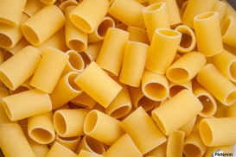
March 12, 2020

Counting Collections at CREC

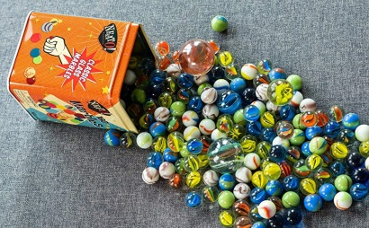
We are counting! Counting Collections is becoming a regular practice in many of our classrooms. Why is counting important? Counting provides the foundation for understanding numbers and for computation skills (addition, subtraction, multiplication, and division).

Counting teaches children:
-the names of numbers
-the sequence of numbers
-one-to-one correspondence
-relative size
-efficient and accurate counting strategies
-the value of organizing in math! It’s easier to keep track of groups of ten than to count 170 single objects!
-skip counting (5-10-15-20 ),
-how to count on from a number (129, 130, 131 )
-how to count groups of objects
-how to represent or record what they’ve counted

What should children count? Everything!!
Buttons, rocks, candy, seeds, hair clips, toys, books, pencils, crayons, blocks, flowers on the wallpaper, etc.

How can you help at home?
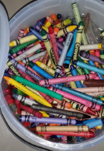
Count out objects out loud together!
Provide objects to count: cereal, macaroni, sunflower seeds, pennies
Give your child cups and plates to organize by tens and hundreds
Show your child how much you love counting too!

Listen to your child count and ask:
-Are they including every number in the sequence?
-Are they touching each item as they count?
-How are they organizing their objects?
-Can they write the number and draw a picture of what they counted?

The more children count, the stronger their number sense will be.

